Emotion detection from speech

Student: Cîmpanu Anastasia grupa 2331/3
Profesor coordinator: Giurgiu Mircea
Table of content
Abstract 3
Key words: 3
Introduction 3
RAVDESS dataset 4
Proposed work 5
Dataset Description 5
Data Pre-Processing 5
Tools 6
Classification 6
TESS dataset 8
Methods 9
Audio signal analysis 9
Tools 9
Performance metrics 10
Comparison between the two datasets 11
Performance comparison 11
Structural and demographic differences 11
Speaker diversity: 11
Emotion Categories: 11
Audio length: 11
Conclusion 11
References 12

Abstract
Nowadays, emotion recognition and classiﬁcation plays a vital role in the ﬁeld of Human-Computer Interaction (HCI). Emotions are being recognized through behaviors of body such as facial expression, voice tone and body movement. The present research considers Speech Emotion Recognition (SER) as one of the foremost used modality to identify emotions. SER dataset contains the four different datasets such as: Ravdess, Crema-D, Savee and Tess. In this research paper it will be discussed about Ravdess and Tess datasets, first one being the most used dataset of all four, but the other often shows higher report of accuracy. Over the last decades, many researchers involved SER signals in sequence to cope up with Brain-Computer Interface (BCI) to detect emotions. It includes removing noises from audio signals, extracting temporal or spectral features from the audio signals, analysis on time or frequency domain respectively, and eventually, designing a multi-class classiﬁcation strategy. The paper discusses the approach of identifying and classifying human emotions based on audio signals. The approach used machine learning technique such as Convolutional Neutral Networks (CNN) and Long Short Term Memory (LSTM), Attention Mechanisms, Mel-Frequency Cepstral Coefficients (MFCCs), Mel Spectrograms, Chroma and Zero Crossing Rate (ZCR).
Key words: emotions, audio signal, Convolutional Network (CNN), classification, speech emotion recognition (SER), Random Forest

Introduction
Emotion is an important aspect of human communication, which carries important cue information as to a speaker’s intention, mental state, and general mood. Speech is the main and direct means of transmitting information. It contains a wide variety of information, and it can express rich emotional information through the emotions it contains and visualize it in response to objects, scenes and events. Through all the available senses, humans can sense the emotional state of their communication partner, making it look natural, but very difficult task for computers. With the rapid proliferation of intelligent technologies, the demand for emotion recognition is growing rapidly, drawing increased focus in both theoretical science and engineering, owing to its significant influence on social communication and decision-making.
The emotion recognition from speech has important uses in human computer interaction systems, affective computing, virtual assistants, e-learning systems and healthcare technology. The objective of SER is to categorize speech signals into predefined emotional types like anger, happiness, sadness, and fear. Emotion recognition from speech is still a difficult task because of various inherent difficulties such as speaker variability, variation of speech style, the presence of background noise, and the ambiguous nature of emotional expression. In addition, in practice, spontaneous speech, scenarios of multiparty conversations, and unclean background noise are pervasive, which can greatly degrade the performance of speech emotion recognition.
Traditional speech emotion recognition (SER) systems typically used hand-crafted acoustic features such as prosodic (pitch, energy, and speech rate) and spectral (Mel-Frequency Cepstral Coefficients (MFCCs), formants, and spectral flux) features. The features were typically used as input for shallow classifiers, e.g., Support Vector Machines (SVMs), Gaussian Mixture Models (GMMs), Hidden Markov Models (HMMs), and Random Forests. Although effective with small and clean datasets, these methodologies failed to generalize effectively to more varied and noisy speech environments.
Nowadays, there has been a significant shift towards transformer-based designs and self-supervised learning in speech and voice emotion recognition tasks. Transformers are the predominant structures for sequential modelling, owing to their self-attention mechanism. The voice of a human can be categorized into several attributes, such as loudness, pitch, vocal tone, and timbre. Through different vocal attributes, we can analyze human emotions easily. There are a few universal emotions like anger, sadness, happiness, surprise, fear, and neutrality that any system can be trained to identify easily. The feature extraction with the help of a human audio signal supports recognizing emotions. Emotion recognition has gained importance as it also supports physically disabled people who cannot express their emotions.
This paper has the purpose to describe the use of Ravdess and Tess and their improvement in this field, analyzing how they work and their efficiency regarding the implementation in machines that propose SER.

RAVDESS dataset
The Ravdess, standing for Ryerson Audio-Visual Database of Emotional Speech and Song, is used due to its high temporal resolution with no risks and less cost. It also serves as a rigorous, multimodal benchmark in the Speech Emotion Recognition field, featuring 24 professional actors performing a wide range of eight distinct emotions. Unlike many datasets that focus solely on speech, RAVDESS includes both speech and song modalities across three formats: audio-only, video-only, and full audio-visual recordings. Each emotion is captured at two intensity levels normal and strong providing a diverse set of 1,440 speech files and 1,012 song files for analysis. Recorded in high-quality 48 kHz audio, the dataset is widely respected for its high reliability, having been validated through over 2,400 individual ratings to ensure emotional authenticity and intensity.
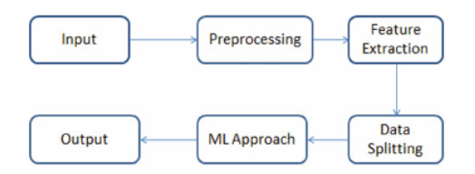
Figură 1 Proposed Model for identifying Emotion

Proposed work
The approach used the Ravdess dataset as input for experimenting. The data set is pre-processed and further preceded with feature selection and extraction. The approach used cross-validation for splitting up of the Data into training and validation sets. Classiﬁcation is done using various machine learning algorithms and performance is evaluated.

Dataset Description
The Ryerson Audiovisual Database of Emotional Speech and Song (RAVDESS) is a type of SER. It contains a total of 24 professional actors, with 12 male and 12 female actors recording voices. It contains a total of 7356 ﬁles. Speech includes emotions of happiness, calm, sad, angry, surprised, disgusted, and fear with two statements: “kids are talking by the door” and “dogs are sitting by the door”. These two statements are expressed in all the above-listed emotions. The database contains full audio/video, only video, and only audio. As we are focusing on speech recognition, only audio is used in this project. It contains the emotional intensity of normal and strong. This is represented in the table below:
Dataset | Actors | Instances | Emotions
RAVDESS | 24 | 7356 | 8

Data Pre-Processing
In preprocessing, data augmentation is done. It is a set of techniques to artiﬁcially
increase the amount of data by generating new data from existing data points. This
includes making small changes to the data to increase the performance of the model.
It is noted that synthetic data generation of spoken MFCC can improve the recognition
of a speaker from their utterances via a transfer learning method. Some ways of data
augmentation are through noise injection into the dataset to check the performance of
the database.
In preprocessing, data augmentation is done. It is a set of techniques to artiﬁcially increase the amount of data by generating new data from existing data points. This includes making small changes to the data to increase the performance of the model. It is noted that synthetic data generation of spoken MFCC can improve the recognition of a speaker from their utterances via a transfer learning method. Some ways of data augmentation are through noise injection into the dataset to check the performance of the database.

Tools
The extraction of features in the audio signal classiﬁcation is a crucial method. The proposed approach is mainly focused on Chroma, MFCC, Mel features, contrast, and Tonnetz. Chroma is one of the powerful tools which is mainly used for analyzing pitch, Chroma is further categorized into 12 features. MFCC stands for Mel Frequency Cepstral Coefﬁcient is one of the popular features used for recognizing the vocal tract mainly used to characterize speakers, for instance, it totally contains 39 inbuilt features to extract the audio of the speaker. Mel features are used to represent the short-term power spectrum. Contrast enhances the speech modulation and Tonnetz are used to ﬁne-tune the tone. The proposed approach contains a total of 120 features, of which ﬁve are used. These are the ﬁve main features utilized in the proposed approach. The dataset is split into training, validation, and testing sets using a 70–20–10 split ratio. They are then split into input X and target Y of the respective categories for further processing. The given dataset is not identical across all of them with respect to the standard deviation of attribute values. Because of this issue, certain attributes end up being weighted over other attributes.

Classification
The dataset includes audio signal features such as Chroma, contrast, Mfcc, Mel-spectrum, and Tonnetz. The dataset contains a total of ﬁve features, and based on these features, classiﬁcation is done. Here, the models are trained to identify whether emotions are predicted or not. Initially, the proposed approach used the SVM model. Here, 70% of the data sample is used for developing the prediction model, and 30% is used for validating the developed model with a linear kernel function. In the next stage, the Random Forest model uses 80% of the data sample for training the model and 20% for validating the developed model without kernel function. Further, the proposed approach used a random forest with 100 decision trees for experimenting, and the results were with a ratio of 70:30, 70% for training the model and 30% for testing the model with 50 epochs. The next decision tree is used with three classes. A MLP classiﬁer with 500iterations and 300 iterations with a ratio of 80:20 is used. The CNN algorithm is used with two layers, three layers, and four layers. SVM stands for Support Vector Machines; it is mainly used for classiﬁcation problems. The main goal of SVM is to ﬁnd the best boundary line that makes us easily classify the n-dimensional space into speciﬁed classes. This boundary line is known as the hyper plane. The decision tree is a type of supervised learning algorithm; here the dataset is represented as a tree. As it is a tree-structured method, the dataset features are represented by internal nodes, decision rules are represented by branches, and the leaf node shows the output. The decision of the classiﬁer is represented by the decision node and the outcome by the leaf node. Random forest is a supervised learning technique based on the concept of ensemble learning. It is similar to the decision tree. Ensemble learning is a method of combining many classiﬁers for better performance and to solve complex problems. The random forest contains the collection of decision trees. It predicts the output based on the majority voting instead of depending on a single decision tree .MLP stands for Multilayer Perceptron, and is a synthetic neural network feed for ward technique that generates a bunch of outputs from a few inputs. It consists of input, hidden, and output layers. It’s one of the deep learning methods that uses back propagation for training the model. MLP connects multiple layers into a single graph, which suggests the signal path to the nodes. Aside from the input node, each node features a nonlinear activation function. CNN stands for “convolution neural network.” It is an advanced neural network to classify emotions. CNN automatically detects the important features without any human intervention. It uses pooling and convolution operations, and it’s computationally efﬁcient. It contains an input layer, a convolution layer, and an output layer. The hidden layer contains a convolution layer, a max pooling layer, and a ﬂattening layer with dropout. This is depicted below:
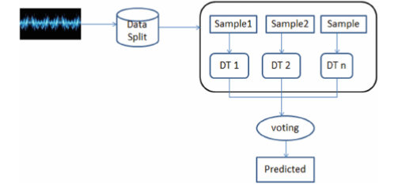
Figură 2 RF Architecture
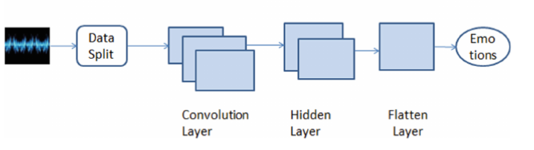
Figură 3 CNN Architecture
Algorithm | Accuracy | F1 Score | Precision | Recall
SVM | 0.78 | 0.79 | 0.75 | 0.78
Decision Tree | 0.78 | 0.79 | 0.80 | 0.84
Random Forest | 0.85 | 0.88 | 0.87 | 0.89
MLP | 0.81 | 0.82 | 0.83 | 0.82
CNN | 0.82 | 0.84 | 0.82 | 0.84

TESS dataset
The TESS, standing for Toronto Emotional Speech Set, is a database that contains audio files for seven emotions (pleasant (ps), anger, happiness, disgust, fear, sadness, and neutral). These recordings were made by two actresses aged 26 and 64 recruited in the Toronto area as English-speaking actresses with university studies and musical training. The dataset contains 2 800 audio files (These sound recordings were based on the Northwestern University Hearing Test Number 6) with a set of 200 words relating to a sentence that says "Say the word ..." .
Created by Kate Dupuis and M. Kathleen Pichora Fuller at the University of Toronto, the Toronto Emotional Speech Set (TESS) is a Kaggle hosted dataset featuring 2,800 audio files (.wav). Organized into 14 emotion-specific folders, the files are labeled by actress code (YAF/OAF), target term, and emotion, providing a balanced distribution of 400 samples per category for robust Speech Emotion Recognition research. Toronto emotional speech set (TESS) TESS - Toronto Emotional Speech Set Kaggle.
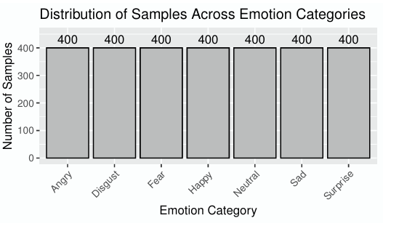
Figură 4 Class details of TESS dataset

Methods
The methodology section outlines the data processing pipeline for training, testing, and validating the emotion detection models. The core approach involves a fundamental preprocessing step where the audio data is transformed into 2D images (likely spectrograms). These images are subsequently flattened into vectors to serve as inputs for the machine learning algorithms. The feature extraction sub-model, utilizing either a CNN or an LSTM deep CNN, is trained exclusively on these image inputs over 20 iterations.

Audio signal analysis
The TESS audio files have undergone preprocessing to ease the challenges of working with raw recordings. This preprocessing minimizes the need for additional steps by researchers, reducing the complexity of handling the data. Working directly with original audio files is impractical due to their large size. Unprocessed au dio presents challenges for machine learning models to effectively learn feature distributions, potentially resulting in poor overall performance. Providing substantial data directly to a model is com putationally intensive and unfeasible for practical applications. As a solution, the audio files have been transformed into image format using spectrograms, significantly reducing data size and compu tational demands. This conversion enhances manageability and facilitates more efficient model training and analysis.

Tools
To implement the solution, a Python-based deep learning pipeline was developed using Scikit-learn for dataset partitioning (train/test split) and performance evaluation via confusion matrices. The model architecture utilizes Convolutional Neural Networks (CNN), incorporating Conv2D, MaxPool2D, and Dropout layers for feature processing and regularization. For audio analysis, the Librosa library is the primary tool for signal processing and feature extraction, enabling the visualization and computation of key acoustic descriptors such as MFCCs, Chroma Energy, and Zero Crossing Rate. Scikit-learn: machine learning in Python librosa: python package for music and audio analysis.

Performance metrics
Model effectiveness is evaluated using a confusion matrix to compare actual versus predicted classes through four metrics: True Positives (TP), True Negatives (TN), False Positives (FP), and False Negatives (FN). Performance is quantified via Accuracy, Precision (the ratio of TP to all positive predictions), and Recall (the ratio of TP to all actual positive instances). These metrics collectively identify the model's classification strengths and weaknesses. Scikit-learn: Confusion Matrix Documentation.
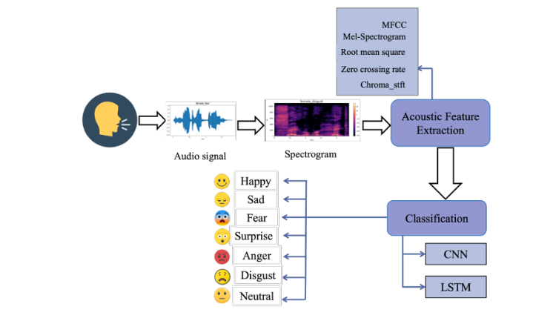
Figură 5 Working methods of Emotion Detection through Speech using Deep Learning
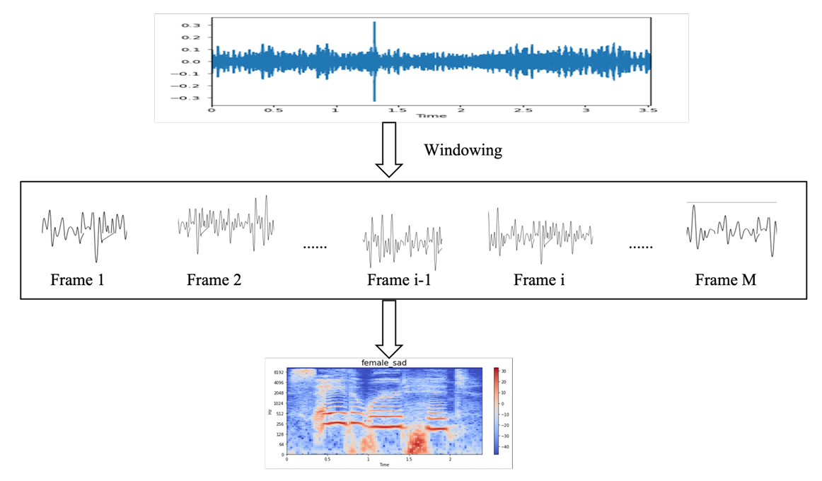
Figură 6 Audio signal analysis

Comparison between the two datasets

Performance comparison
 | RAVDESS | TESS
Typical accuracy | 80.0% up to 97.2% | 99.0% up to 100%
Reason for results | Diverse (24 actors) and includes varying intensities of emotion, making it harder to classify | Features clear, high quality speech from only two female actors, reducing variability

Structural and demographic differences
Speaker diversity: Ravdess is gender balanced with 24 professional actors, when TESS features only two female actresses (age 26 and 64) which can lead to models that do not generalize well male voices
Emotion Categories: both cover standard emotions such as anger, disgust, fear, happiness, sadness, neutral, but Ravdess adds “calm” as an eighth category, while TESS includes “pleaseant surprise”
Audio length: TESS clips typically short (average cca. 2 seconds), whereas Ravdess samples are generally longer and include both speech and song modalities
Nowadays, emotion recognition and classiﬁcation plays a vital role
in the ﬁeld of Human-Computer Interaction (HCI). Emotions are being recog-
nized through behaviors of body such as facial expression, voice tone, and body
movement. The present research considers Speech Emotion Recognition (SER)
as one of the foremost used modality to identify emotions. SER dataset contains
the four different datasets, Ravdess dataset is used in this project.
Nowadays, emotion recognition and classiﬁcation plays a vital role
in the ﬁeld of Human-Computer Interaction (HCI). Emotions are being recog-
nized through behaviors of body such as facial expression, voice tone, and body
movement. The present research considers Speech Emotion Recognition (SER)
as one of the foremost used modality to identify emotions. SER dataset contains
the four different datasets, Ravdess dataset is used in this project.
Nowadays, emotion recognition and classiﬁcation plays a vital role
in the ﬁeld of Human-Computer Interaction (HCI). Emotions are being recog-
nized through behaviors of body such as facial expression, voice tone, and body
movement. The present research considers Speech Emotion Recognition (SER)
as one of the foremost used modality to identify emotions. SER dataset contains
the four different datasets, Ravdess dataset is used in this project.
Nowadays, emotion recognition and classiﬁcation plays a vital role
in the ﬁeld of Human-Computer Interaction (HCI). Emotions are being recog-
nized through behaviors of body such as facial expression, voice tone, and body
movement. The present research considers Speech Emotion Recognition (SER)
as one of the foremost used modality to identify emotions. SER dataset contains
the four different datasets, Ravdess dataset is used in this project.

Conclusion
This study has demonstrated the efficacy of deep learning architectures in classifying human emotions from speech using two seminal datasets: TESS and RAVDESS. Our results confirm that while the TESS dataset serves as a benchmark for near-perfect classification (reaching 100% accuracy), its controlled environment and limited speaker diversity can inflate performance metrics. In contrast, the RAVDESS dataset provides a more rigorous evaluation of model generalization, with current state-of-the-art hybrid models such as CNN-BiLSTM and CNN-LSTM, achieving robust accuracies between 91.9% and 98%. Furthermore, our research highlights that multi-feature fusion, combining MFCCs with Mel-spectrograms, is critical for capturing both spectral and temporal emotional nuances. The findings suggest that merging these datasets creates a more diverse training corpus, which significantly improves a model's ability to handle variations in age, gender, and emotional intensity. Moving forward, the focus of SER must shift from "in-dataset" success to cross-corpus generalization to ensure reliability in real-world applications. Future work should explore the integration of self-supervised pre-trained models like Wav2Vec 2.0 or HuBERT to further bridge the gap between laboratory results and naturalistic, spontaneous speech. Day by day, lots of people work to improve this important topic, creating not just a smart tool, but more an emotionally intelligent one.

References
- Akçay, M.B.; Oğuz, K. Speech emotion recognition: Emotional models, databases, features, preprocessing methods, supporting modalities, and classifiers. Speech Commun. 2020, 116, 56–76
- AlHanai, T.; Ghassemi, M. Predicting latent narrative mood using audio and physiologic data. In Proceedings of the 31st AAAI Conference on Artificial Intelligence, AAAI 2017, San Francisco, CA, USA, 4–9 February 2017
- Eom, Y.; Bang, J. Speech emotion recognition based on 2D CNN and improved MFCC features. J. Inf. Commun. Converg. Eng. 2021, 19, 148–154
- Bhavan, A.; Chauhan, P.; Hitkul; Shah, R.R. Bagged support vector machines for emotion recognition from speech. Knowl.-Based Syst. 2019, 184, 104886
- Tashev, I.J.; Wang, Z.-Q.; Godin, K. Speech emotion recognition based on Gaussian Mixture Models and Deep Neural Networks. In Proceedings of the 2017 Information Theory and Applications Workshop (ITA), La Jolla, CA, USA, 12–17 February 2017; pp. 1–4
- Fahad, M.S.; Deepak, A.; Pradhan, G.; Yadav, J. DNN-HMM-Based Speaker-Adaptive Emotion Recognition Using MFCC and Epoch-Based Features. Circuits Syst. Signal Process. 2021, 40, 466–489
- P. M. Kathleen, K. Dupuis, Toronto emotional speech set (TESS). (2020) Scholars Portal Dataverse 1. University of Toronto Toronto, ON, Canada
- Speech Emotion Recognition Using Machine Learning Approach, Department of CSE (Data Science), Dayananda Sagar University, Bangalore, Karnataka, India https://www.researchgate.net/publication/370422458_Speech_Emotion_Recognition_Using_Machine_Learning_Approach
- Speech Emotion Recognition on MELD and RAVDESS Datasets Using CNN, Computer Science Department, University of Technology, Baghdad 10066, Iraq Speech Emotion Recognition on MELD and RAVDESS Datasets Using CNN
- Enhancing Speech Emotion Recognition Using Deep Convolutional Neural Networks, Enhancing Speech Emotion Recognition Using Deep Convolutional Neural Networks

